**# Visual Studio 2022 for Mac - Preferences - Build and Debug - SDK Locations Apple**

**Apple SDK**

Xcode 15.4 found at specified location.

Location: Application/Xcode.app

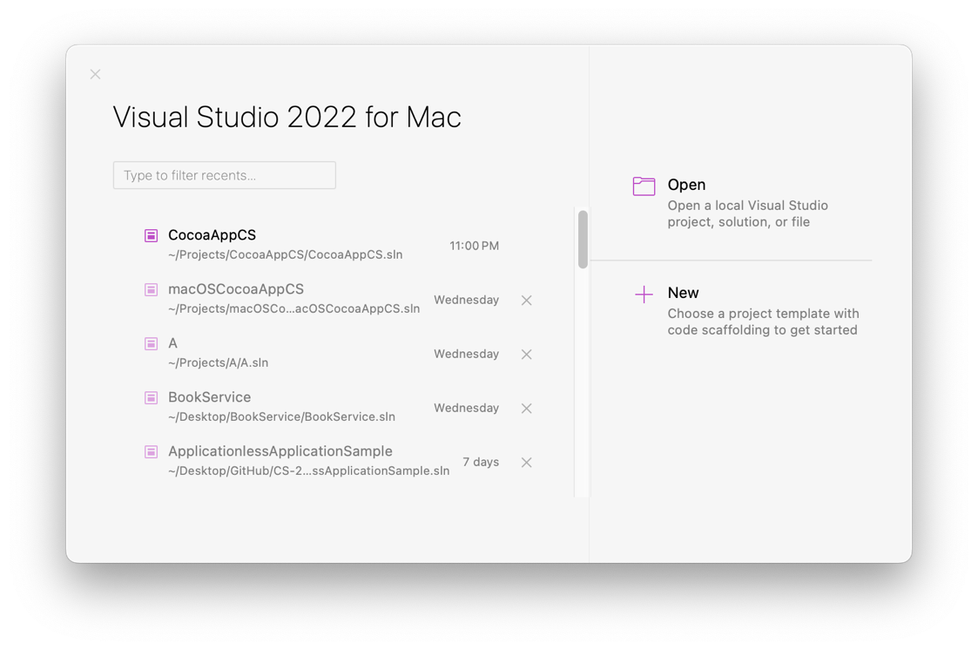

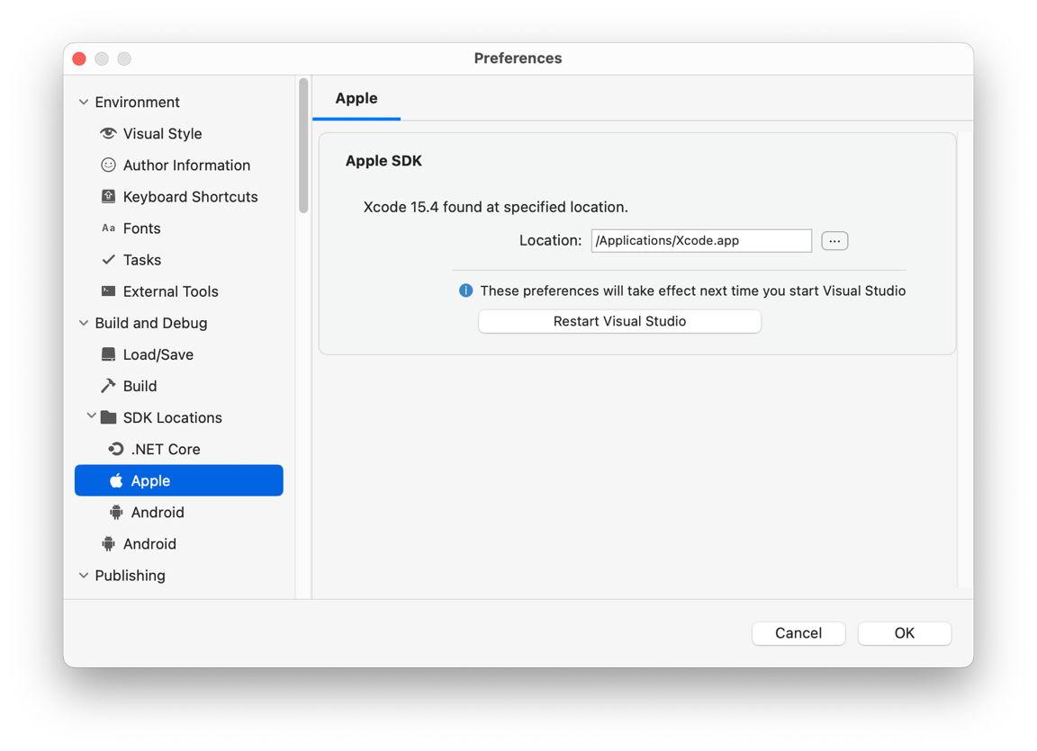

**# NB**

Xamarin.Mac 9.3.0 does not support a deployment target of 14.0 for macOS (the maximum is 13.3). Please select an older deployment target in your project's Info.plist or upgrade to a newer version of Xamarin.Mac

**# Visual Studio 2022 for Mac**

• + New

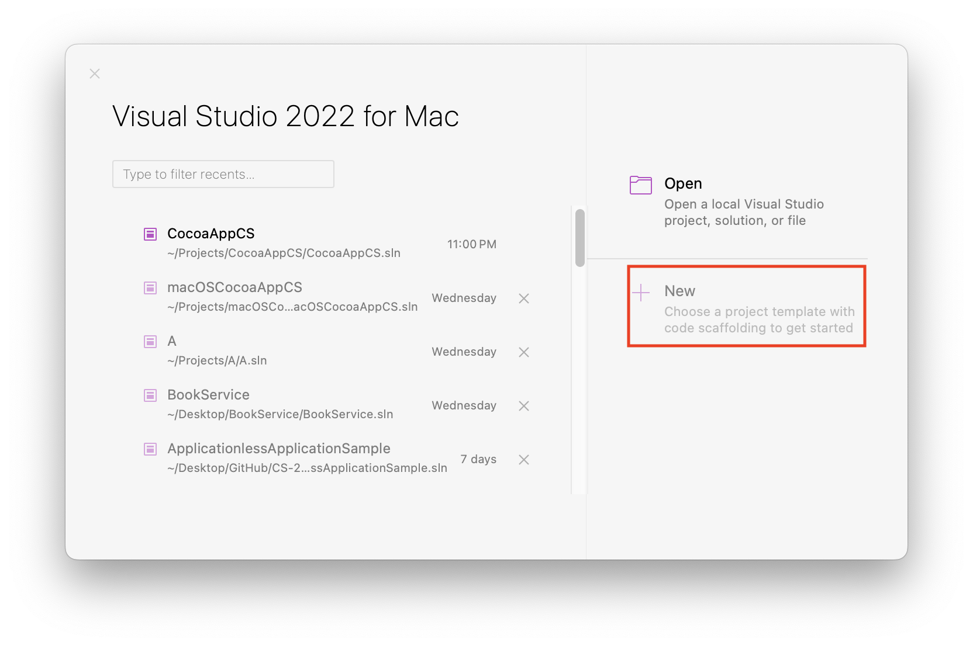

**• Choose a template for your new project**

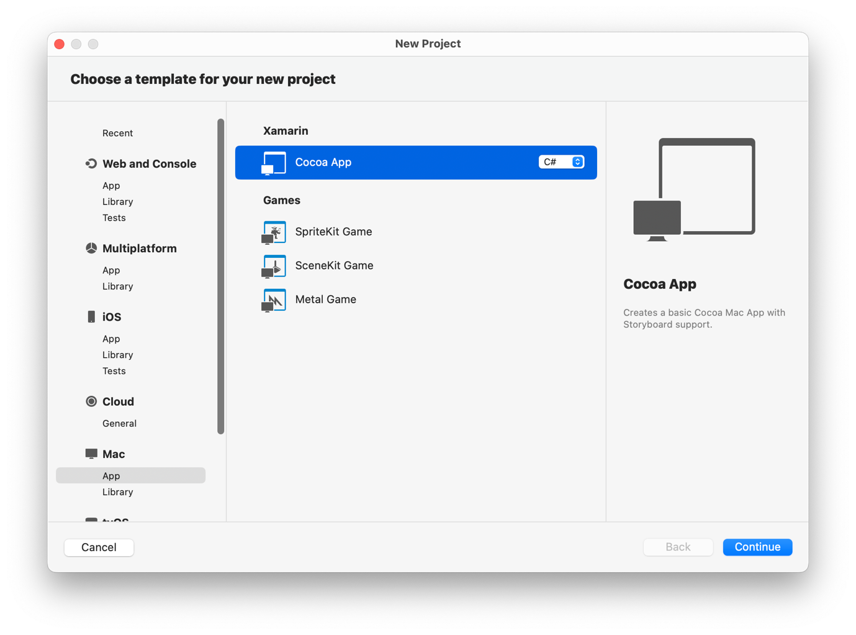

Mac - App - Cocoa App (Xamarin) C#

**Continue**

**• Configure your Mac project**

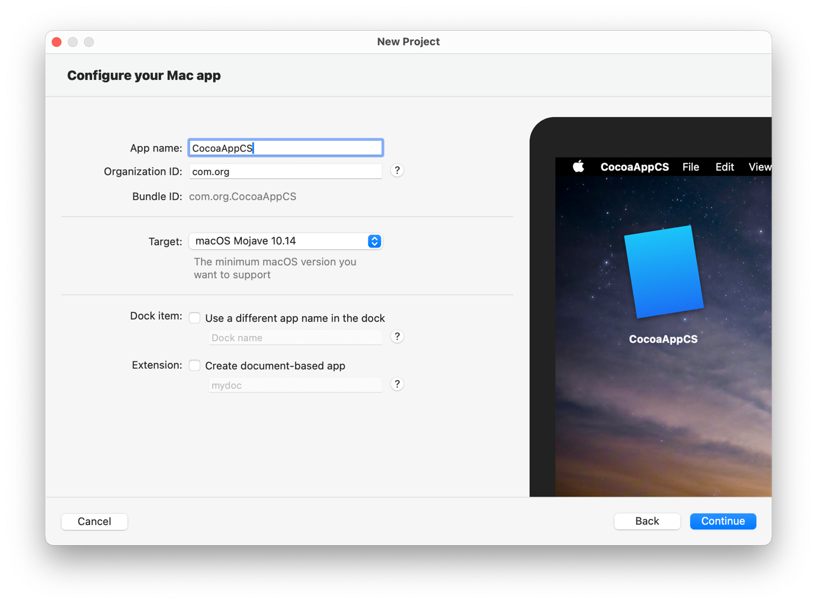

App name: CocoaAppCS

Organization ID: [com.org]

[Build ID: com.org.CocoaAppCS]

Target: macOS Mojave 10.14

**Continue**

**• Configure your new Cocoa App**

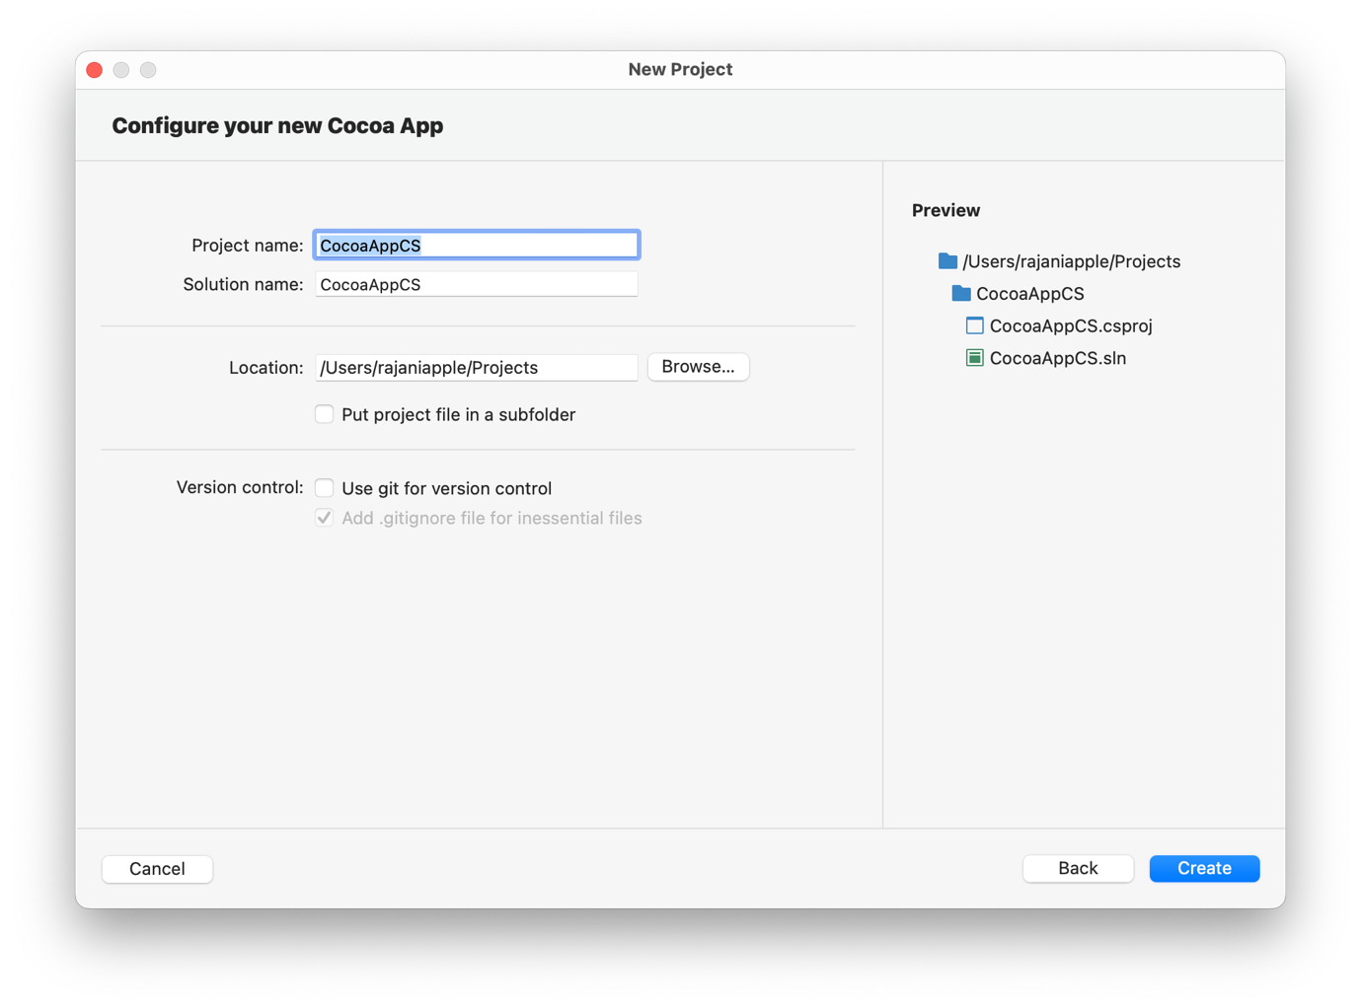

Project name: CocoaAppCS

Solution name: CocoaAppCS

Location: [/Users/username/Projects]

**Create**

**• Run the project**

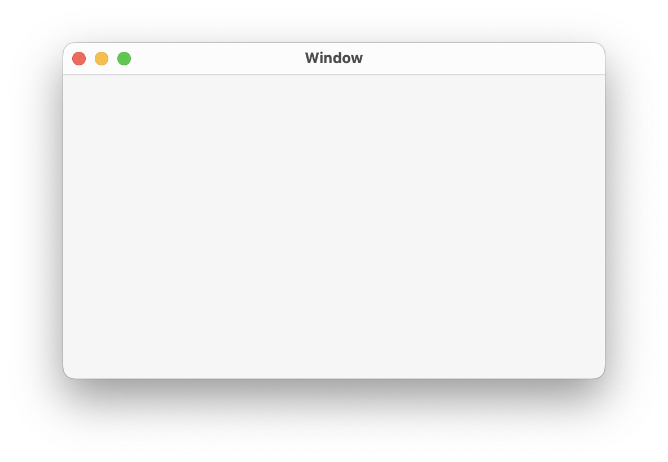

[Blank Window]

**• Right click Main.storyboard and select Open With > Xcode Interface Builder**

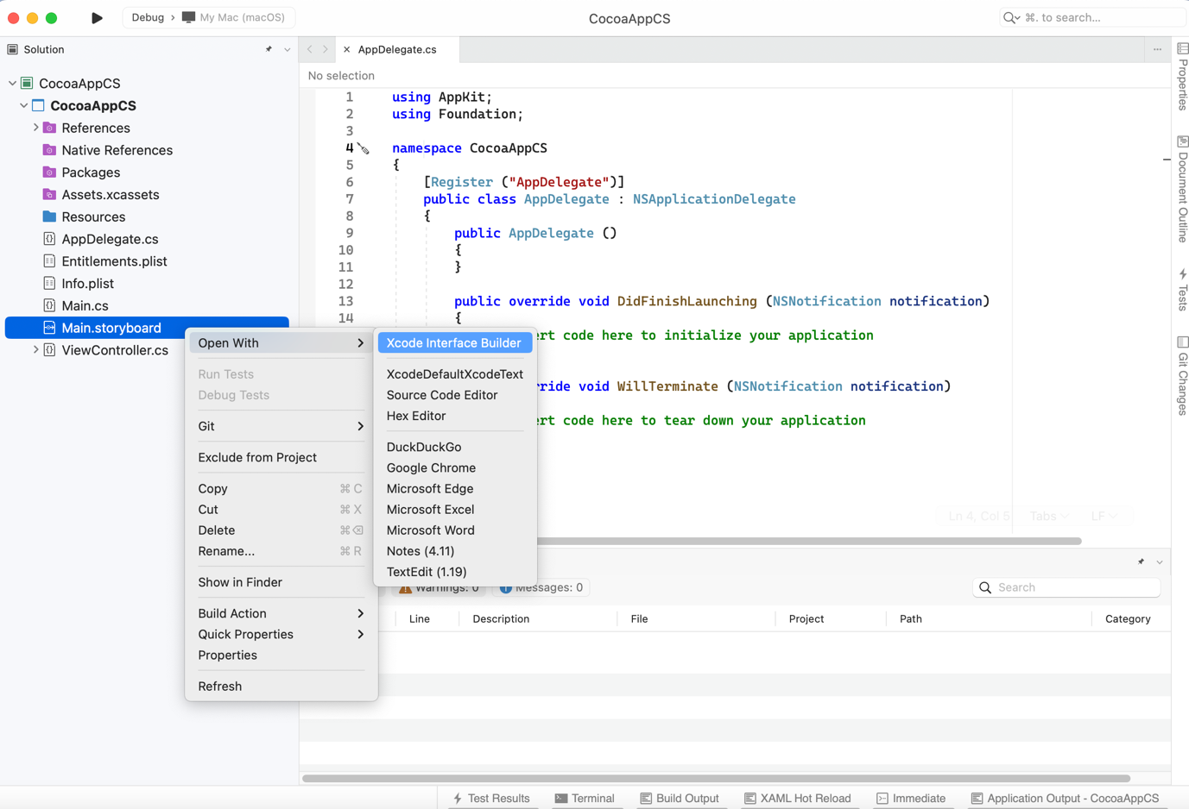

**# Xcode**

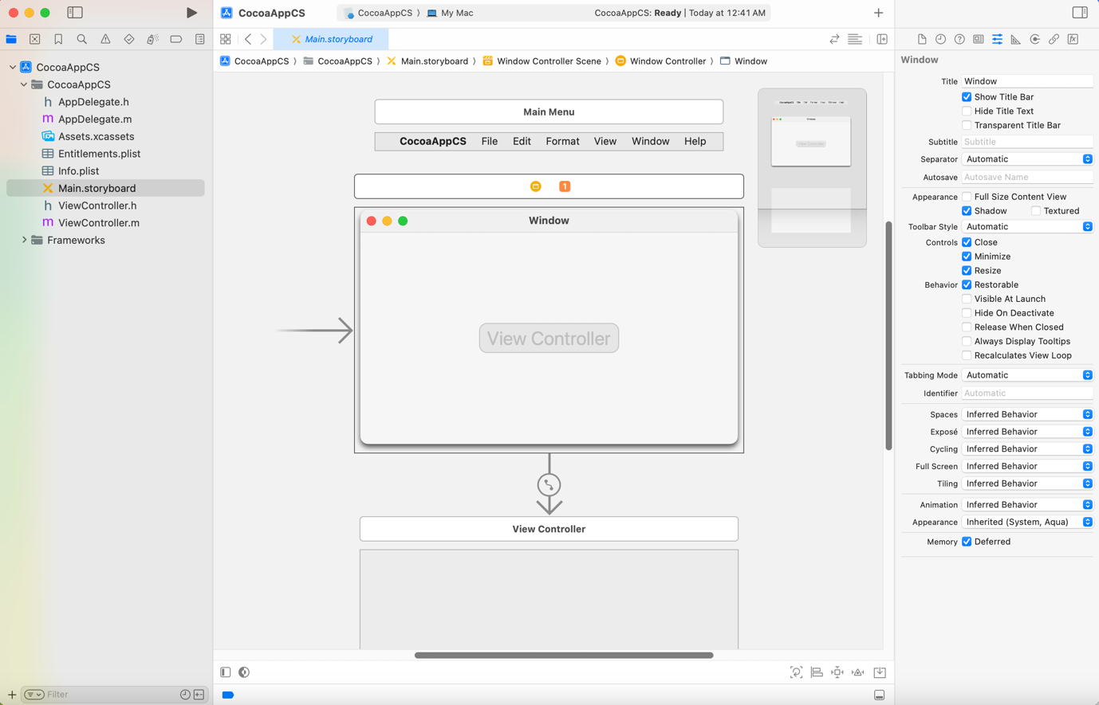

**• Xcode Menu - View - Show Library [ Shortcut ( command + shift + L ) ]**

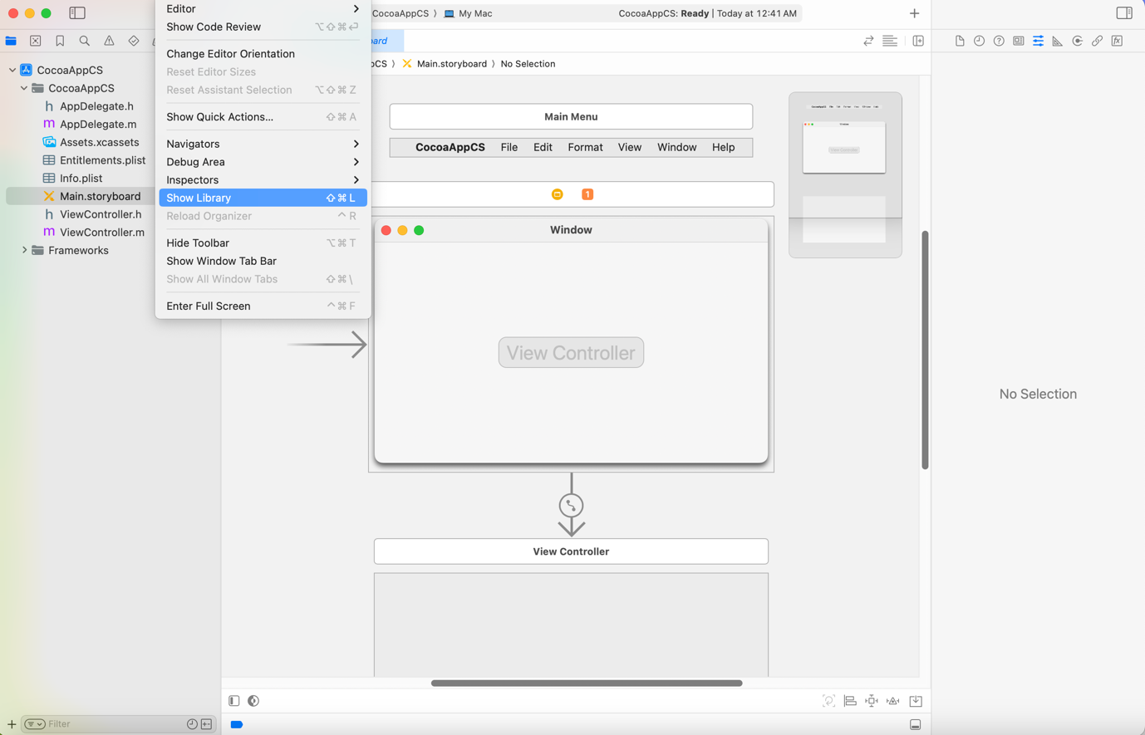

**• Xcode Objects**

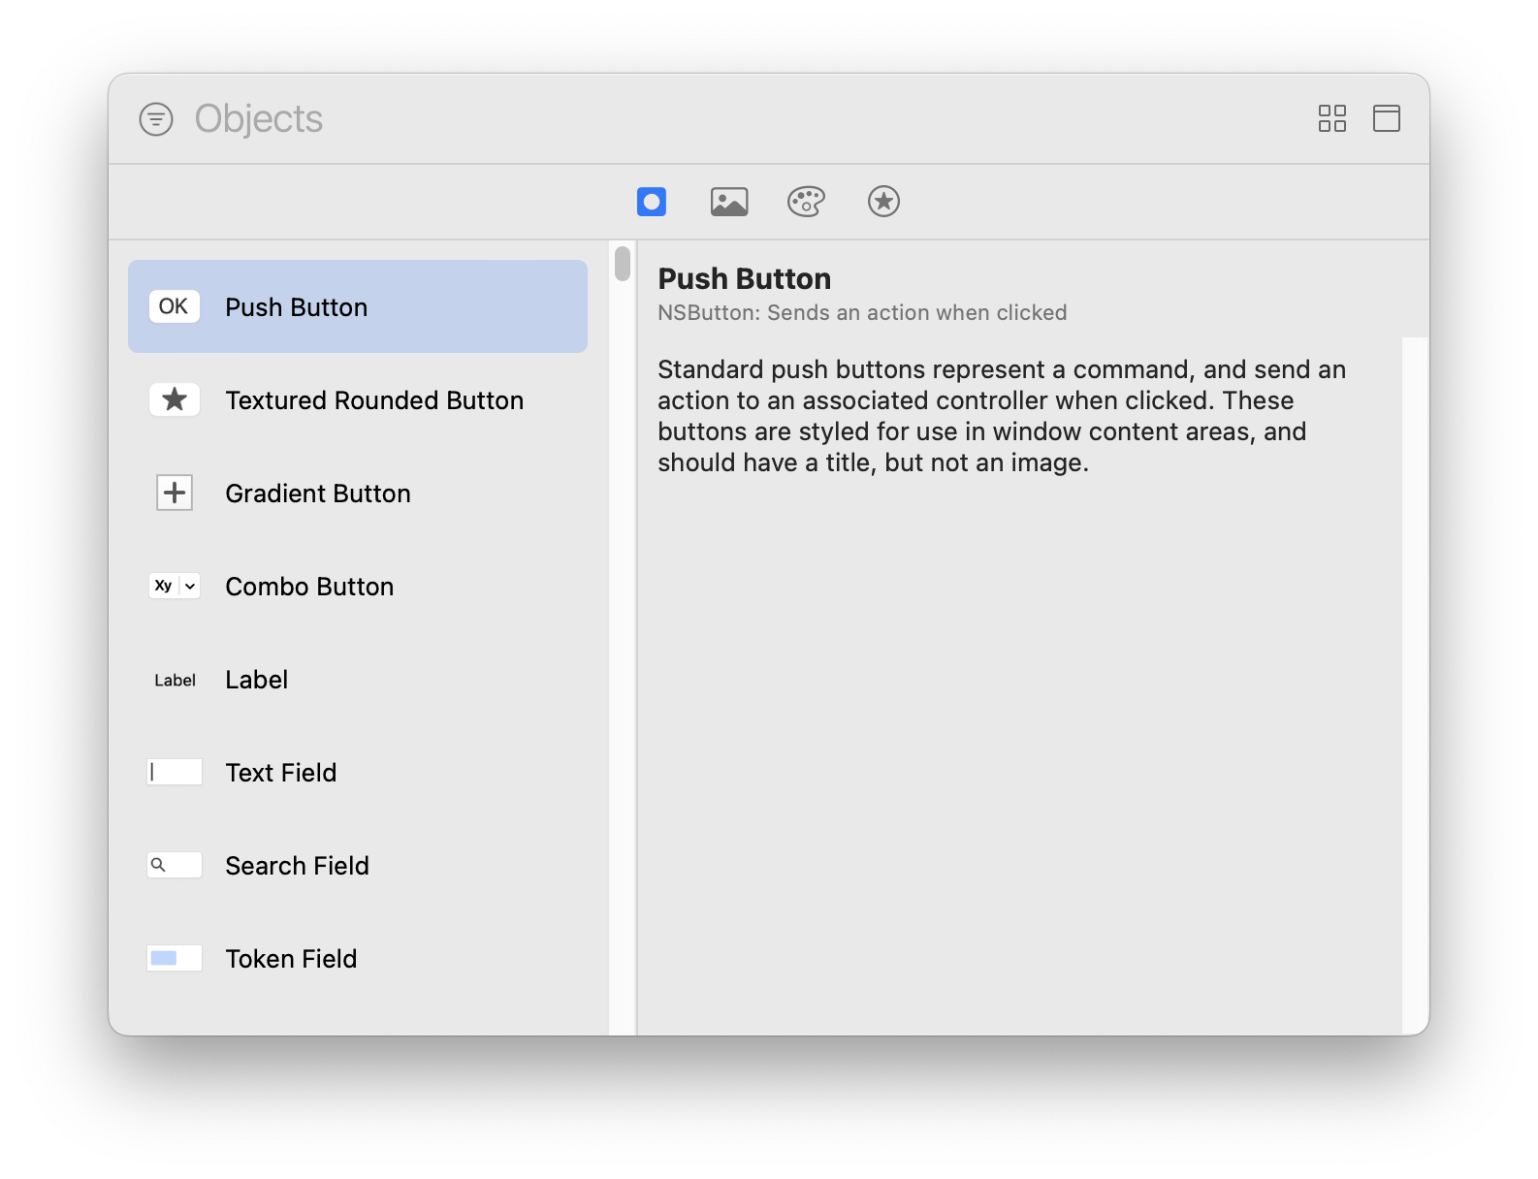

**• Select the Objects(s) and drag the Objects(s) to ViewController**

**1. Select Push Button Object and drag it to ViewController [Double Click the Push Button Object and Enter Text viz, "Click for Time"]**

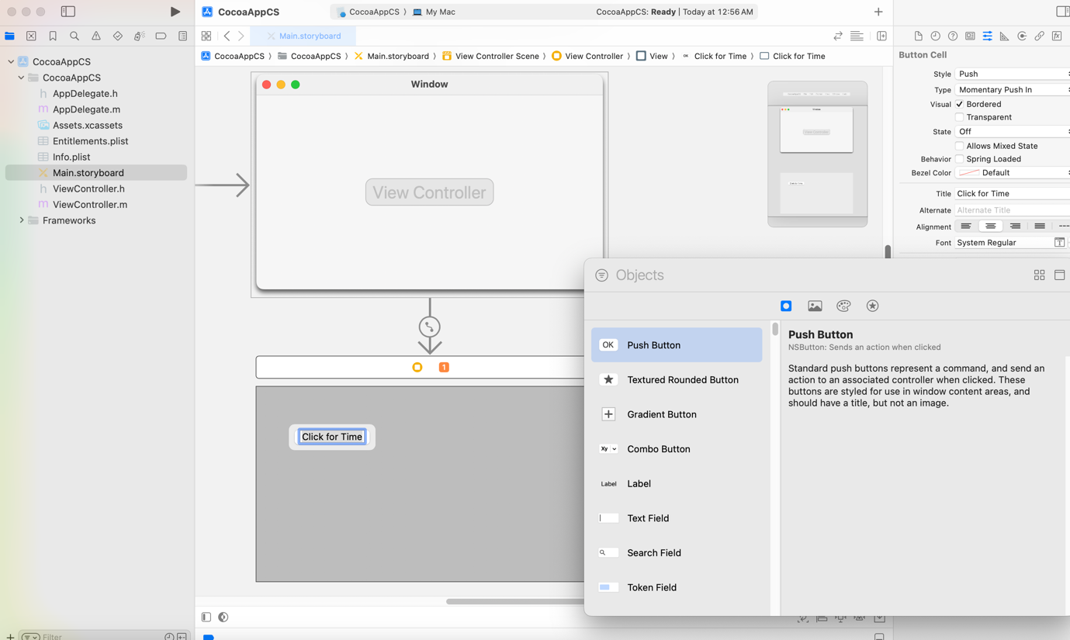

**2. Select Label Object and drag it to ViewController [Double Click the Label and Clear the Text "Label" and Expand the Label in ViewController]**

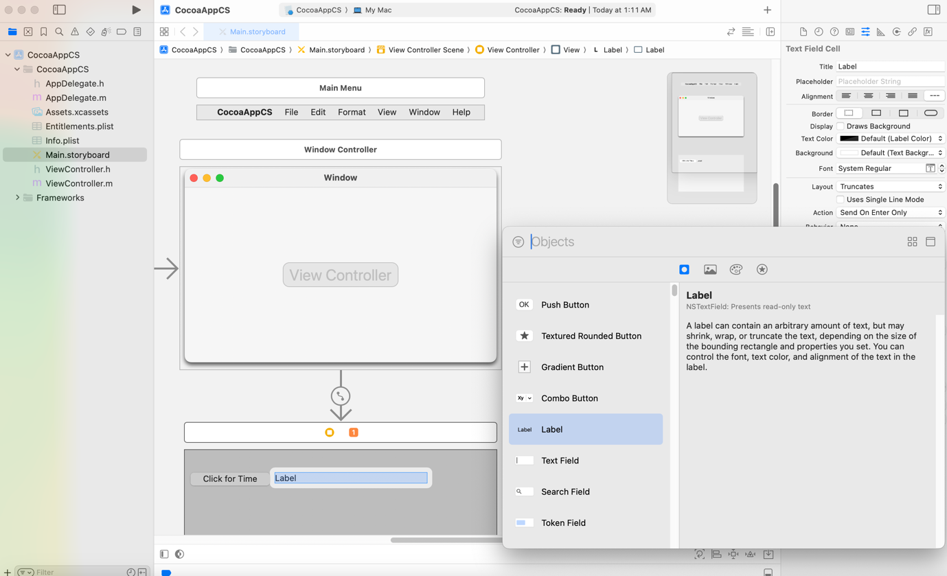

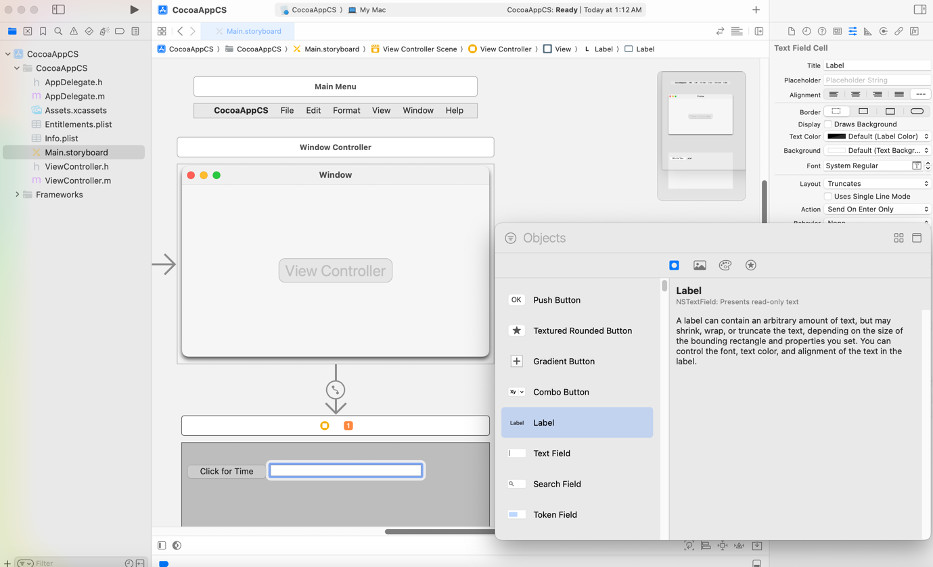

**• Xcode Side by Side Main.storyboard and ViewController.h**

Click Add Editor on Right [Icon Located on Top Right Corner of the Window]

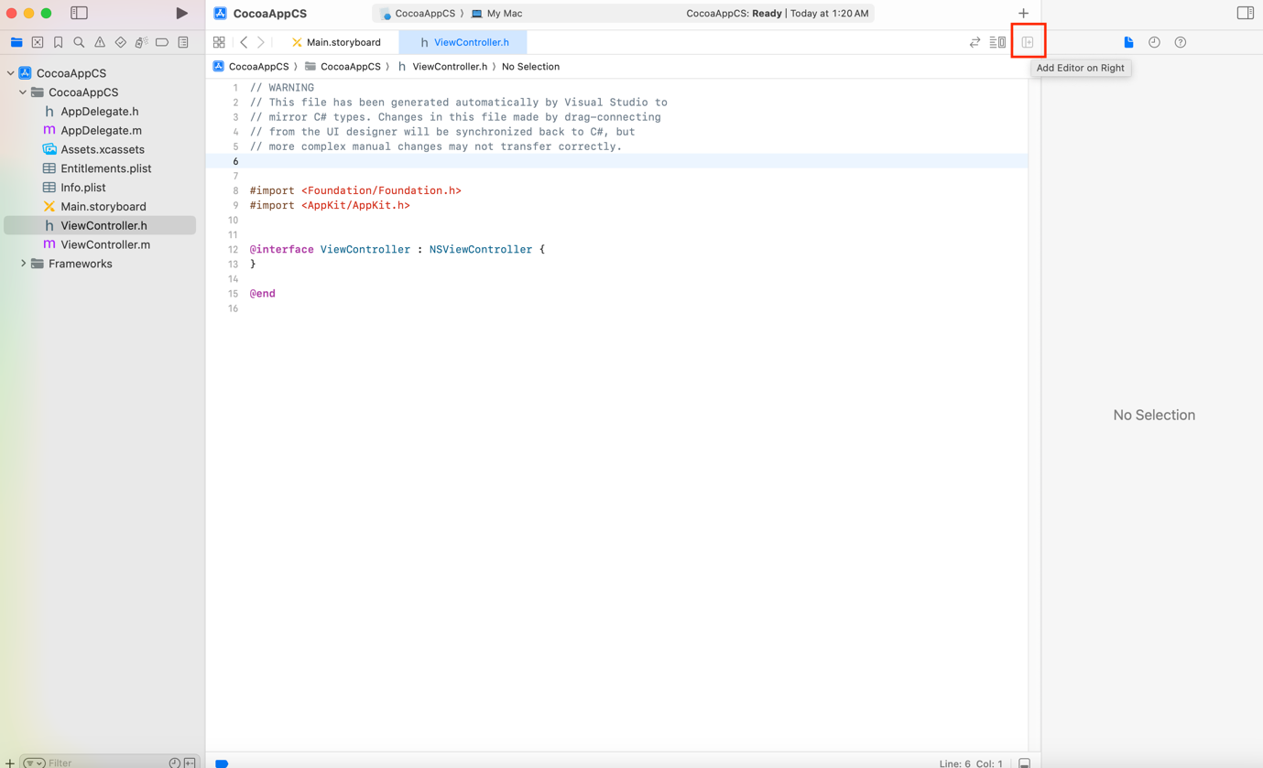

Navigate between Main.storyboard and ViewController.h

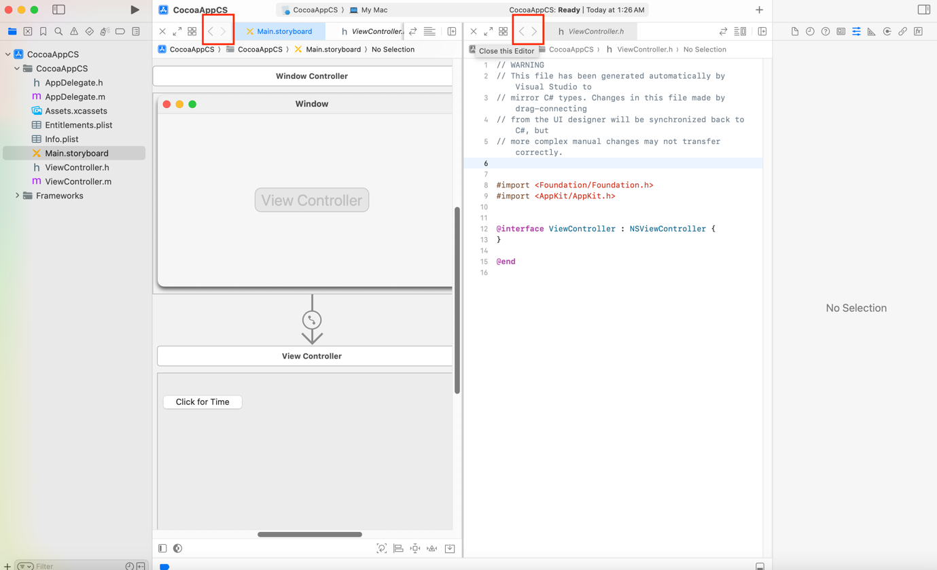

**1. control and drag and drop Push Button Object to ViewController.h below:**

@interface ViewController : NSViewController {

}

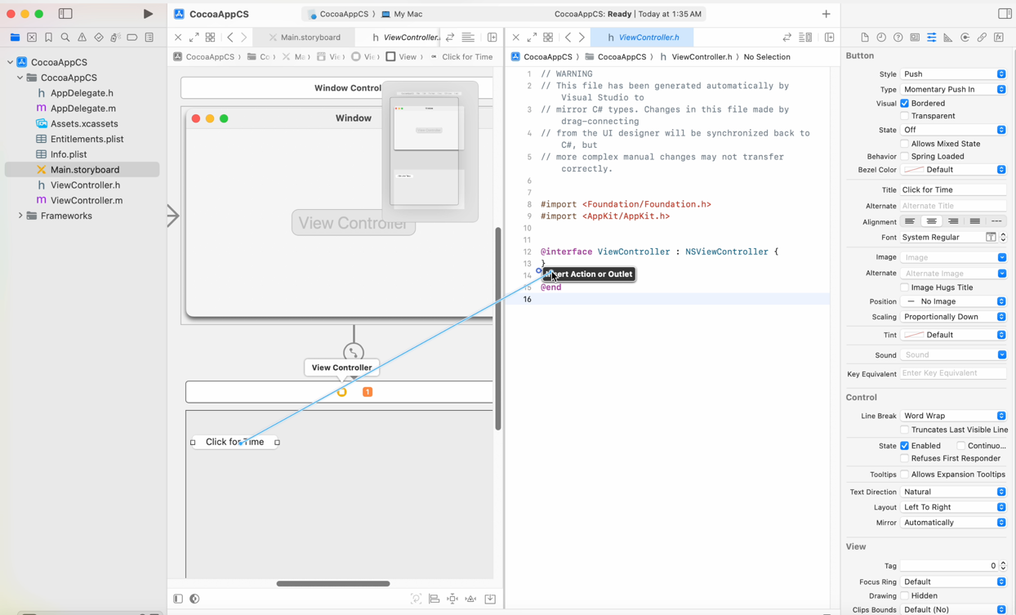

**• Push Button Object**

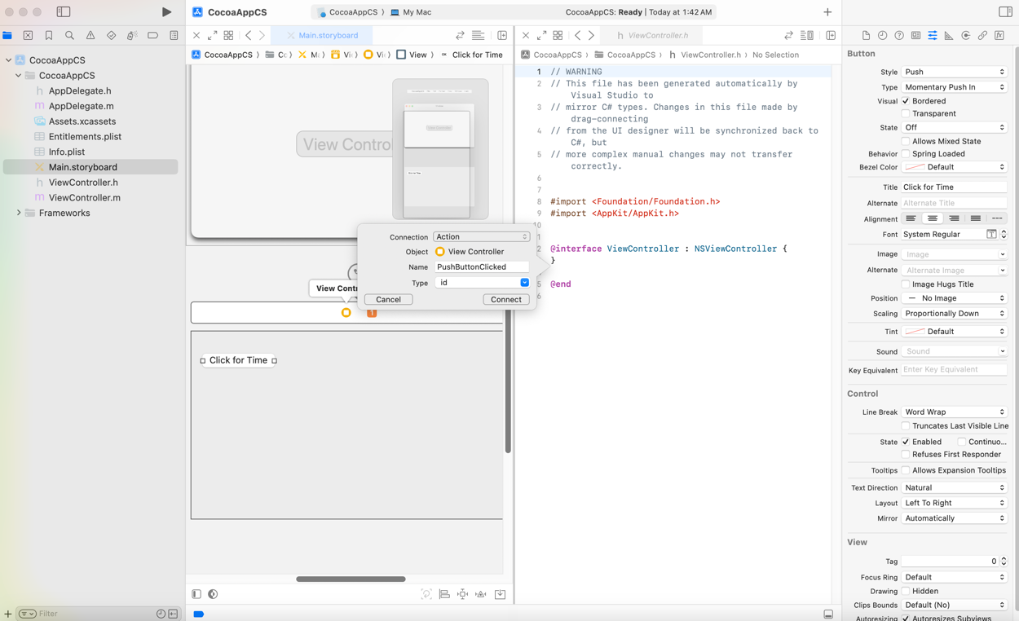

Select Connection: Action

Enter Name: PushButtonClicked

Type: [id]

Connect

**2. control and drag and drop Label Object to ViewController.h below:**

@interface ViewController : NSViewController {

}

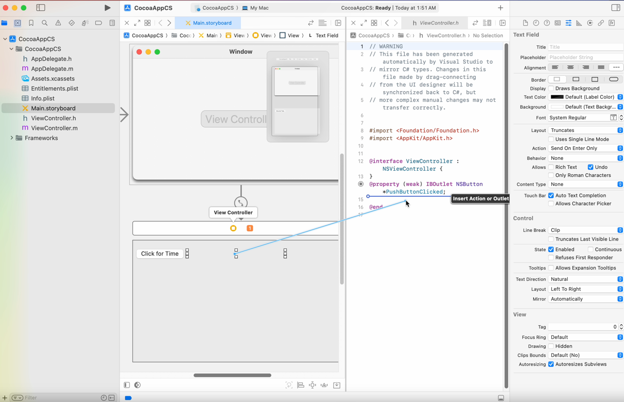

**• Label Object**

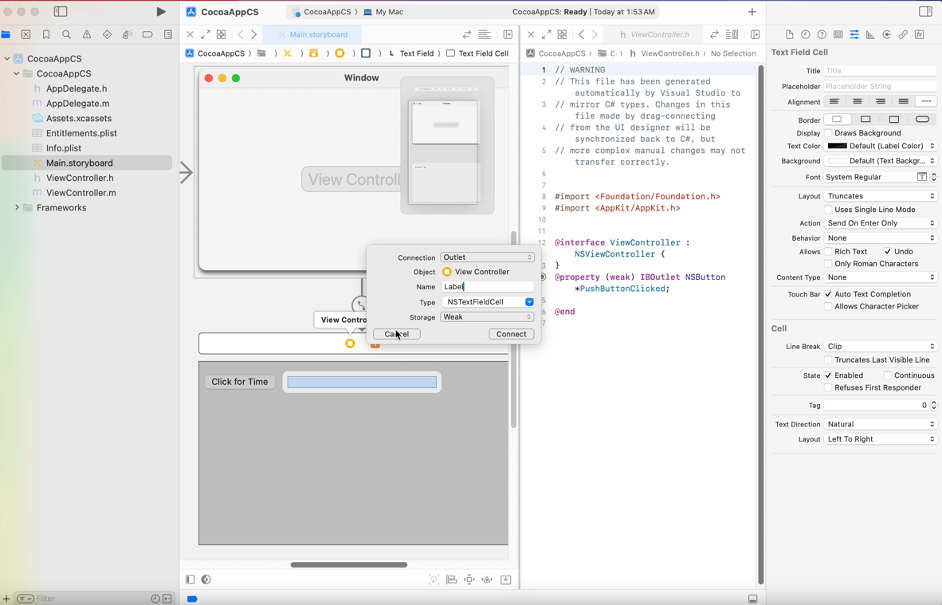

Select Connection: [Outlet]

Enter Name: Label

Connect

• Save and Close Xcode

**# Visual Studio 2022 for Mac**

• ViewController.designer.cs

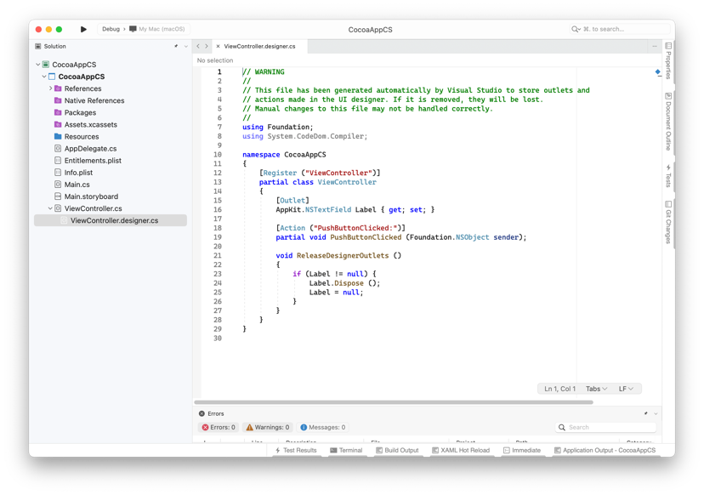

**• Check for the following in ViewController.designer.cs [Do not edit]**

// WARNING

//

// This file has been generated automatically by Visual Studio to store outlets and

// actions made in the UI designer. If it is removed, they will be lost.

// Manual changes to this file may not be handled correctly.

//

using Foundation;

using System.CodeDom.Compiler;

namespace CocoaAppCS

{

[Register ("ViewController")]

partial class ViewController

{

[Outlet]

AppKit.NSTextField Label { get; set; }

[Action ("PushButtonClicked:")]

partial void PushButtonClicked (Foundation.NSObject sender);

void ReleaseDesignerOutlets ()

{

if (Label != null) {

Label.Dispose ();

Label = null;

}

}

}

}

**• ViewController.designer.cs**

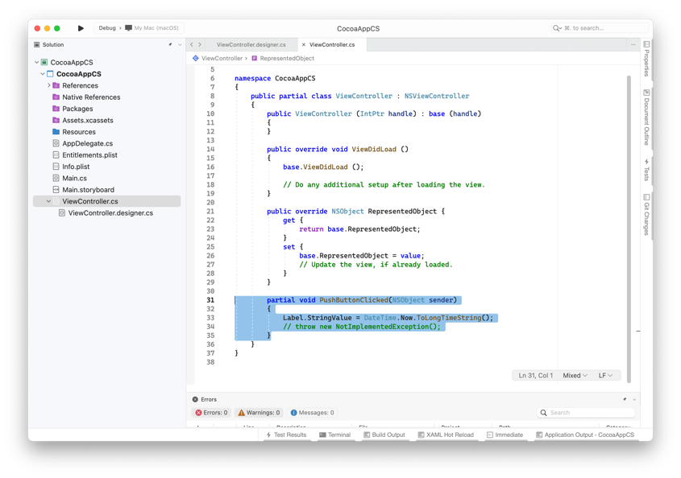

• Add the following event handler to partial class ViewController : NSViewController in namespace CocoaAppCS public

partial void PushButtonClicked(NSObject sender)

{

Label.StringValue = DateTime.Now.ToLongTimeString();

// throw new NotImplementedException();

}

**• Final code in ViewController.cs**

using System;

using AppKit;

using Foundation;

namespace CocoaAppCS

{

public partial class ViewController : NSViewController

{

public ViewController (IntPtr handle) : base (handle)

{

}

public override void ViewDidLoad ()

{

base.ViewDidLoad ();

// Do any additional setup after loading the view.

}

public override NSObject RepresentedObject {

get {

return base.RepresentedObject;

}

set {

base.RepresentedObject = value;

// Update the view, if already loaded.

}

}

partial void PushButtonClicked(NSObject sender)

{

Label.StringValue = DateTime.Now.ToLongTimeString();

// throw new NotImplementedException();

}

}

}

**• Run the project**

**[Window]**

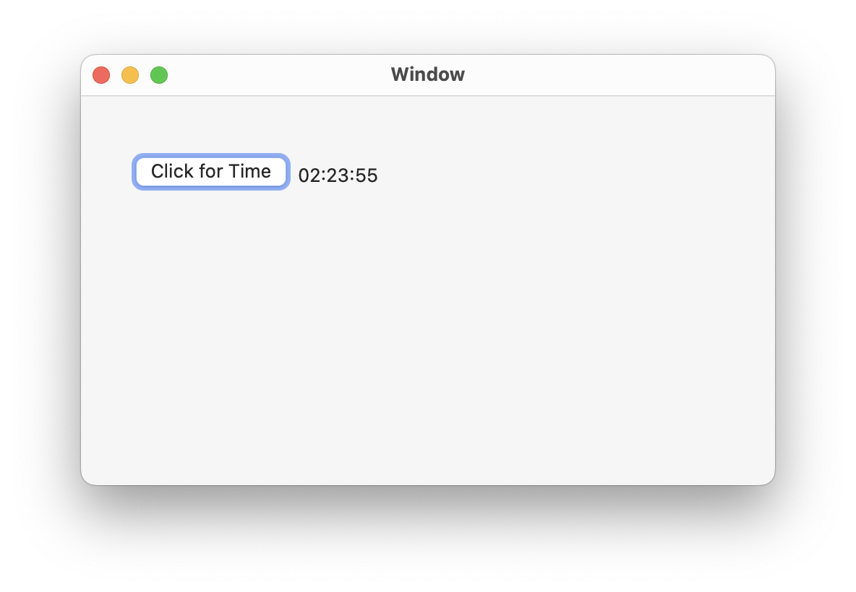

Click the button "Click for Time" to see the time in the label